# MZUMBE UNIVERSITY



**FACULTY OF SCIENCE AND TECHNOLOGY**

**(FST)**

**FIELD PRATICAL TRAINING REPORT**

**PROGRAMME:** BSc.ITS

**YEAR OF STUDY:** FIRST YEAR

**DEPARTMENT:** COMPUTING SCIENCE STUDIES.

**COMPANY NAME:** MISUNGWI DISTRICT COUNCIL

**ICT SUPERVISOR:** MR. LUKO MTEKELE.

**MU SUPERVISOR:** DR.TUPOKIGWE

**REGISTRATION NUMBER:** 14322049/T20.

**NAMES OF STUDENT:** RENATUS MISANA PIUS.

# 

### DECLARATION

I hereby declare that this report has been prepared by me to fulfill the curricular requirement of Bachelor in Information Technology and systems (BSc.ITS) year one field work offered by Mzumbe University (MU)

Prepared and Written By

SIGNATURE: ………………………………….

NAME: RENATUS MISANA PIUS

DATE: ………………………………….

### CERTIFICATION

This is to certify that all rights have been reserved and no part of this report may be reproduced, distributed, or transmitted in any form or by any means, including photocopying, recording, or other electronic or mechanical methods, without the prior written permission of the author, except in the case of brief quotations embodied in critical reviews and certain other noncommercial uses permitted by copyright law.

MU supervisor

Signature …………………………………….

Date …………………………………

## 

### ACKNOWLEDGMENT

My carrier Field work was not easy from very initial beginning to the eventual end, it required support and input from different sources as well as individuals to attain a broad objective. Therefore, I bound to express my gratitude to all those who cared and spent their time to assist and provided mentorship whenever I needed asupport.

Firstly,I like to thank almighty God for making me healthy throughout the practical training until now when writing this report. Also special to our lovely parents and sponsors’ who assisted us financially and ensured that Iwas undertaking my field work comfortably.

I am highly indebted to express my special thanks and appreciation to University CSS department particularly my field supervisor Dr. Tupokigwe for his exception support which made my field work easier and had grate input in the assessment and accomplishment of this report successfully.

Secondly, I would like to extend special gratitude to the management of MISUNGWI DISTRICT COUNCIL for granting me an opportunity to undertake this practical training at their organization. special thanks go to Madam Leokadia G. Humera (Misungwi District Executive Director), Mr. Said, Miss Restuta, Mr. Lubuga, and Mr. Bruno, (Human resource team) Mr Joseph Nkwabi, Mr. Luko Mtekele, Mr. Clement Moshi (District Information technology Officers) for allowing me conducting the practical training at their facility.

### ABBREVIATIONS

CD - Compact Disc

CPU - Central Processing Unit

DHCP - Dynamic Host Configuration Protocol

DVD - Digital Versatile Disc

GOT-HOMIS - Government of Tanzania Health Management

Information System.

GoT-HoMIS - Government of Tanzania Hospital Management

Information system

HDD - Hard Disc Drive

ICT - Information Communication Technology

IMIS - Insurance Management Information System

IP - Internet Protocol

IT - Information Technology.

LAN - Local Area Network

LED - Light emitting diode

MIS - Management Information System

MU - Mzumbe University

NIC - Network interface controller

OS - Operating System

RAM&ROM - Random Access Memory& Read Only Memory

RITA - Registration Insolvency and Trusteeship Agency

RJ45 - Register Jack

USB - Universal Serial Bus

### ABSTRACT

The field work practical took six consecutive weeks to be oriented on issue we learnt and practice and see how they relate from those issues discussed at the university.

I waslucky to be accepted at **Misungwi district council** where I reported from 31st August 2021 to 15thoctober 2021. Through training I gained much skills and experience. How to act, dress and kind of language to use in a working environment. At Misungwi District Council I wasattached to the ICT department together with other students from other colleges.

Most of the Misungwi District departmental units’ services are integrated with information and communication technology (ICT) in service delivery such as healthcare delivery by enabling information access and supporting healthcare operations, Education, Accounts, planning and land survey.

During my six weeks of field studies I performed various tasks such as Identifying parts of computer both software and hardware, working and practicing on Microsoft Applications including word, excel, power point, also working on computer system such as DHIS, Networking and how to solve network problem on PC, data entry, computer maintenance, installing programs such as Anti-virus and Window and connecting different devices through cables to the computer other means.

Besides the all cooperation we got from District staff we faced some challenges such as luck of transportation to peripheral facilities in some occasions when we were to implement ICT related duties, Apart from that there was also little attention given to us by our mentors due to shortage of staves in ICT department.

**TABLE OF CONTENTS**

DECLARATION i

CERTIFICATION ii

ACKNOWLEDGMENT iii

ABBREVIATIONS iv

ABSTRACT v

LIST OF FIGURES viii

**CHAPTER ONE 1**

**INTRODUCTION 1**

1.4 Background of the Organization (Misungwi District Council) 3

1.5 Roles and activities of ICT Department. 3

**CHAPTER TWO 4**

2.0 Assigned Task 4

2.1 PC Maintenance. 4

2.2 Installation of windows. 4

2.3 Installation of Microsoft office 5

2.4 Creating table of content. 5

2.5 Printing a document. 6

2.6 Network troubleshooting maintenance and repair 7

2.7 Configuration of printer network. 8

2.8 Installing of missing system drivers. 9

2.9 Antivirus installation, activation and updating. 9

2.10 Troubleshooting a HP Laser Jet printers. 10

2.11 Data Entry 10

2.12 Ethernet cable installation 10

**CHAPTER THREE 12**

**NEW KNOWLEDGE GAINED 12**

3.1 Network troubleshooting and configuration. 12

3.2 Installation and configuration of printers and scanners. 12

3.3 How to disabled programs that run on startup 13

3.4 Training on the GoT-HoMIS. 14

**CHAPTER FOUR 18**

**CHALLENGES 18**

4.1 Computer fails to install an operating system 18

4.2 Limited number of staffs. 18

4.3 Access to information 18

**CHAPTER FIVE 19**

**CONCLUSION AND RECOMMENDATION 19**

5.1 Conclusion 19

5.2 Recommendation. 20

**REFERENCES 21**

### LIST OF FIGURES

Figure1. GOT-HOMIS client registration form view. 15

Figure 2. GOT-HOMIS cashier site tales 15

Figure 3. GOT-HOMIS OPD site tales 16

Figure 4. GOT-HOMIS laboratory site tale. 16

### 

### 

### CHAPTER ONE

### INTRODUCTION

Field work is the process of converting theory knowledge into practical. As part of component of the Course of information technology and Systems, it is mandatory to undergo a period oftime as practical training on issue we learnt, exercise and experience how they relate to lesions learnt at the university.

I took my practical training at Misungwi District Council from 31st August 2021 to 29thOctober, 2021. Misungwi District Council consists has various department such as Primary and Secondary Education department, Finance, Agricultural, Forestry and bee keeping, Health, Community development, Human resource, Land and survey, Planning, ICT, Procurement and Health department

# VISION

“The vision of Misungwi district council is to enhance good livelihood to its people by ensuring suitable and sustainable social-economic service through good governance.

# MISSION

“The mission of Misungwi district council is to ensure the community and all stakeholders participate in provision of suitable social economic service using the available resources and enabling environment including good governance.”

THE ORGANIZATION STRUCTURE OF MISUNGWI DISTRICT COUNCIL

FULL COUNCIL

DISTRICT EXECUTIVE DIRECTOR

LIVESTOCK AND FISHING

HEALTH DEPARTMENT

LEGAL OFFICER

INTERNAL AUDITING UNIT

SECTION BEEKEEPING

ELECTION UNIT

PROCUREMENT UNIT

INFORMATION &TECHNOLOGY

SECONDARY EDUCATION DEPARTMENT

AGRICULTURE, IRRIGATION AND COOPERATIVE

PRIMARY EDUCATION DEPARTMENT

PLANNING STATISTICS AND COORDINATION

FINANCE DEPARTMENT

HUMAN RESOURSE DEPARTMENT

### 1.4 Background of the Organization (Misungwi District Council)

Misungwi district is one of the seven councils in Mwanza region. It is situated in the Southern part of the region. The district shares border with Mwanza city to the North Shinyanga rural to the South, Sengerema and Geita region to the west Kwimba district to the East and Magu district to the North-East. The district has total area of 2,553km2 of which 2,378km2 is land and 175km2 is covered by water of Lake Victoria. The district was established in 2000, the district is divided into four division of MisungwiMbarika, Inonelwa, and Usagara comprising of 50,697 household, 635 Hamlet's 27 wards and 86 registered villages. There are 36 councilors out of whom 27 are elected, 9 are special seats and one Member of parliament representing Misungwi consistent. The council deals mainly with different activities that are very important to the people around Misungwi since they mainly deal with agriculture, fishing, projects, construction of buildings such as dispensaries, hospitals, classes, laboratory. The council also provide fund to the ones who are responsible for these activities.

### 1.5 Roles and activities of ICT Department.

1. Managing organization Network
2. Provision of technical support (IT department can ensure that the computers and office machines are working)
3. IT department produce apps based on Organization’s needs.
4. Guide the organization with technical support concerning information technology.
5. Maintains the Organizations equipment’s

### CHAPTER TWO

### 2.0 Assigned Task

During the practical training at Misungwi District Council I were assignedto several activities as illustrated bellow.

### 2.1 PC Maintenance.

To make sure that all the systems are working in their good manner in such a way that there will not be any physical fault that might cause the system to fail /collapse /backfire.

Another task that involvedmaintenance was about cleaning the CPU case by using the blower,repairing the computers keyboard cleaning it to remove the accumulated dust.

### 2.2 Installation of windows.

The organization had several computers (7 laptops and 16 Desktops) which had to be installed with the newest version windows 10 and some computers that required a change of windows because the window that were running were either corrupt or very outdated and due to security reasons. On top of that I had to do windows activation on some of the computers there at the facility. In some computers ghost installation was used which including clearing of all data in HDD before installation.

**Steps applied in window installation**

* Inserting Bootable Windows 10 pro DVD in DVD ROM Drive or bootable USB.
* Next select your language, keyboard type (Generally US) and time format
* Click Install button.
* Click the box labeled “I agree with the license terms” and click Next to proceed further.
* In the next screen click on Custom (advanced) option. I hope you are not upgrading here. [If you are doing an upgrade then just clicks on the Upgrade option.]
* Select the Partition to install a copy was chosen, normally the Operating System installed in drive C.
* Typed the Computer name, username and password for the user account security.
* To finalize the installation the option of protecting the computer with recommended options and the GMT zone were chosen. Chose an option of Work Network for using Internet at work place. Therefore, window was successful be installed.

### 2.3 Installation of Microsoft office

Iwas also assigned to install Microsoft office and other application in 12 computers after Window installation.

Procedures to follow when we install Microsoft office.

* Insert Office USB driver into USB port.
* Once the USB is open, run setup as administrator.
* Click Install Now for system with no office or Upgrade for system with low version of Office. Setup will start installation.
* Click close to finalize Installation.

### 2.4 Creating table of content.

Through daily departmental reports Iwere assigned to insert table of content compile every detail prior submission to respective authorities.

**How to insert a table of contents: -**

I used the built-in heading styles. You can create a table of contents that is based on the custom styles that you will add to your document.

* 1. **Select the text**, then on the Home tab, in the Styles group, **click** will change that text to be a style for the Table of Content
  2. Now that your document has styles added to specific entries for your table of contents you are ready to add a Table of Contents.
  3. Click where you want to insert the table of contents, at the beginning of a document. If you need to add a blank page at the beginning, click on Insert tab, Blank Page. Have your cursor sitting at the place you want to table to be.

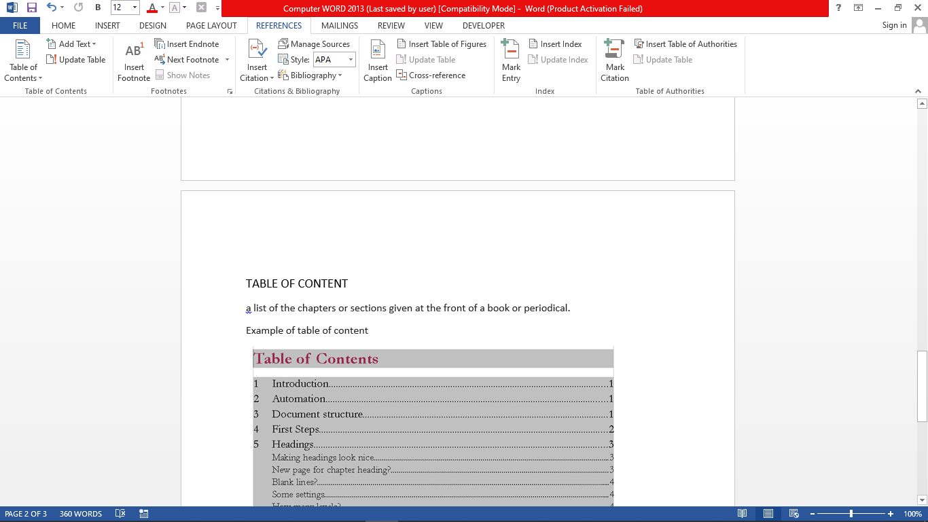

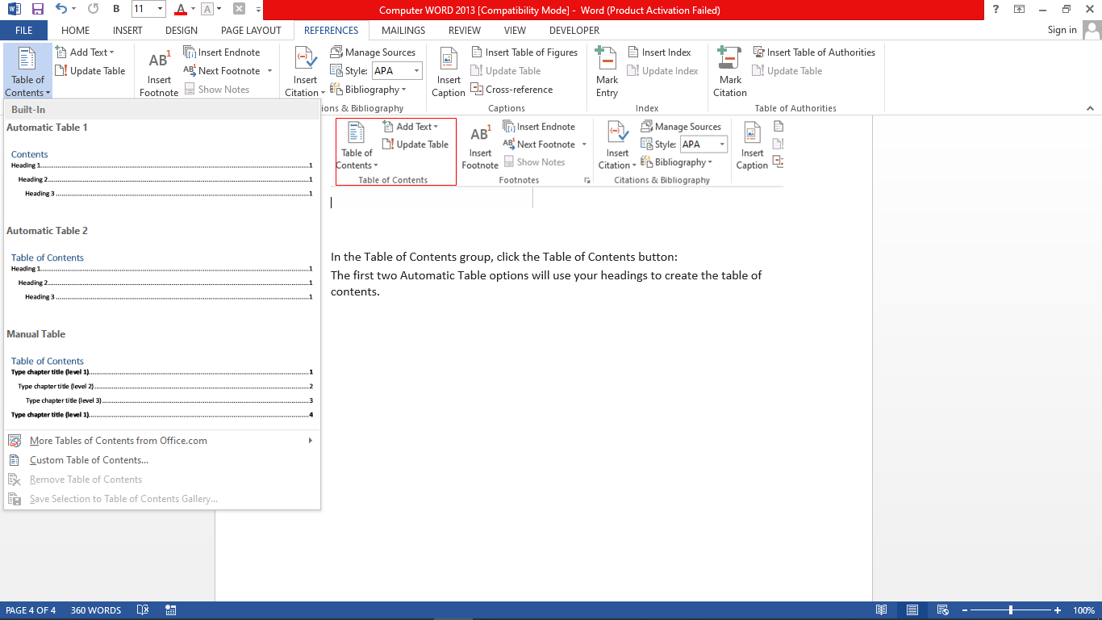

### 2.5 Printing a document.

Most of the organization’s activities ware done through paper work which originated from softcopy to hard copy. I ware oriented on how to print different type of works from Workers identification card, and normal paper printing.

**Steps**

1. **Click** on the **File tab** and **select the Print option** to print your current document **this will display the Print window options**,
2. Along with a preview of the document to the right, such as the range of pages to print.
3. The number of copies to print,
4. After customizing your preferences then **click print to initiate the process**.

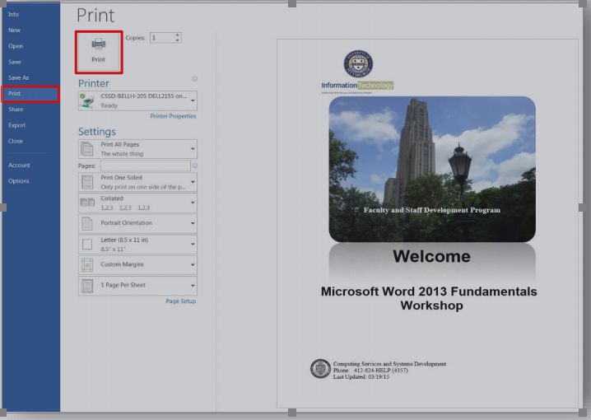

### 2.6 Network troubleshooting maintenance and repair

The organization offices rooms have the computers that is wired so as to allow connection around the computer. The Ethernet cables are closed together in a trunk RJ-45 socket the Ethernet cables originating from the faceplates are connected to the computers.

During the practical training I did some troubleshooting to the network that has failed to enable the communications to users.

* The first approach that I used to troubleshoot the connections among the devices is the most basic one that involves **the physical connectivity of the cables to their respective ports**. This is a very basic and common problem that involves physical connectivity of network cable detachment from the network socket (PORT). Sometime the cables fail to link the communications due to other different factors such as wearing and tearing of the cables. For my case I**resolved the network issue by reconfiguring the network cable andreplacing them with new ones**. Some of the computer in the system where not able to communicate with server. This was what generally did to solve the issue of network connectivity for all computers but to reach such a conclusion I had to follow a series of step so that I could easily determine the best solution regarding the network connectivity. For each computer with such problem (Network connectivity Problem) the following were the steps I followed during the Network troubleshooting so as to determine the problem:

1. Ping the gateway IP or the Server IP.
2. If no response, check the network logical configuration such as IP address.
3. Check if the LAN connection is active by checking the LAN LED indicator in the NIC card.
4. Look for any physical damage in the cable, replace the cable if damaged.
5. Check the cable if the cable configuration (straight through or cross-over) is appropriate for that particular connection.
6. **Finally Building an ethernet crossover cable.**

**The steps were as follows,**

* Determine the cable lengthrequired according to the need.
* Cut off a piece of cable to the desired length using a wire striper normally we remove 5.08cm of the cable jacket.
* Re-organise the four pairs of twisted cables.
* Flattern, straighten and line up the cables using the thumb and forefinger.
* Ensure the cable wire are in the correct order which is white-orange, orange white-green, blue, white-blue, green, white-brown and finally brown.
* Place the RJ-45 connector on the end of the cable, firmly insert the wires into RJ-45 connector and all the wires should be seen at the end of the connector in their proper positions and finally use the crimping tool to force the wires to hold firmly.

### 2.7 Configuration of printer network.

At Misungwi District Council there were many printers and most of them are shared amongst with other computer that are connected to the internet because the printers are network printers. In order for them (printers) to communicate they need to be identified by IP address over the network. Each printer is assigned or has its unique IP address that enable it to be easily recognized/identified by computer when a user wants to access printer for printing a particular document.

### 2.8 Installing of missing system drivers.

Most of the computers in which new operating system was installed faced the problem of missing some important drivers that would make them fully functional. These drivers included network controller and graphic drivers. The MISUNGWI DISTRICT COUNCIL had a copy of universal drivers which were very useful in repairing the missing drivers in the computers and I managed to get some other driver over the internet.

### 2.9 Antivirus installation, activation and updating.

Iinstalled antivirus in operating systems. The type of anti-virus used was Kasperspy antivirus. After the installation of antivirus, I configured the Anti-Virus for a schedule scan which would take place once a week while the computer is idle and custom scan whenever new mass storage device in connected to the system. and for the case of updating,Iwas entered the license product key number to activate online.

Steps

During installation I used the following procedures;

1. The user needs to open the operating system of the laptop and insert CD in the disk drive slot available on the device.
2. Select my computer or my PC folder and open the program with right-click the mouse to start the installation process.
3. Follow the necessary steps, until the installation will bring the necessary assistance to the user by guiding through the process.
4. The user should accept/agree the license that show all terms and conditions of the ant-virus program.
5. The user is required to remove the CD after the installation complete.
6. The user is required to recommended to restart the laptop so that the new program’s setting can properly take place in the operating system of the laptop.

### 2.10 Troubleshooting a HP Laser Jet printers.

Iwas asked to check and resolveprinters’problems: -

* Failing to print where **due to lack of enough tonner** where we replaced the worn-out tonner with new tonner.
* The other major issue was **paper jamming** in the printer’s paper tray. I had to open up the printer’s hatches so that I can remove the jammed papers from the printer

It was my duty to make sure that all the systems are working in their good manner in such a way that there will not be any physical fault that might cause the system to fail accidentally. And through this I leart how to do a proper maintenance to make sure the system will not break down.

### 2.11 Data Entry

### RITA

Iwasassigned to transfer data of under-five enrolled in RITA register (Registration Insolvency and Trusteeship Agency) from birth-register book of health facilities into RITA database. The details were the Names of registered clients, gender, name of parents, Postcode, Nationality, date of birth and registration date. (we managed to 3,528 forms in the system)

1. Orientation on how to use RITA offline Data base.
2. Data entry through phones in offline mode.
3. The entered data were then uploaded in the system.
4. Evaluation of data is done by the authorized user through tracking of information on line.

### 2.12 Ethernet cable installation

Iwas assigned to formulate ethernet cable.I opted to use straight through instead of cross over type to connect computer to switches or hubs. Cross over is mostly used to connect computer to computer.

Straight through is the method that I used during my field time because our mentor advised that,it is the one mostly used in local area networks. Straight though configuration uses a one wiring standard where as both ends can either use T568A wiring standard or T568B wiring standard.I applied the technic during LAN construction of 4 health facilities for **GoT-HoMIS**frame-work installation.

### CHAPTER THREE

### NEW KNOWLEDGE GAINED

During My Practical Training at Misungwi Disrtict Council I leant about the communication skills Vertically to employees within ICT department and other departments, seniorsand horizontally with fellow students from other learning institutions, I also leant about official dressing codes and adapted to the working condition in accordance to the office conduct, apart from this I also learnt knew skills such as: -

### 3.1 Network troubleshooting and configuration.

Ilearnt on procedures and steps to troubleshoot the network problems, such procedures are as restarting the switch, checking the RJ connector if it is well connected with the CPU, running network troubleshooting commands like Ping and checking the active connection from server.

### 3.2 Installation and configuration of printers and scanners.

Ilearnt on how to download required drives for a particular printer and add them to the computer so that the printer may work. When you purchase a printer, the installation and configuration information is usually supplied by the manufacturer. An installation CD that includes drivers, manuals, and diagnostic software will be included with the printer. The same tools may also be available as downloads from the manufacturer's website.

Go through this checklist to prepare the printer for installation. Once the printer has been unpacked and placed in position, connect it to the computer, network, or print server and plug it into an electrical outlet.

* Check the box to ensure all required cables are provided.
* Remove packing materials from the printer and plastic inserts from the consumables.
* Place printer in position. Ensure that the printer location will not cause overheating.
* Install the toner or ink cartridge in the printer.
* Install paper trays.
* Install paper.
* Read and follow the instruction manual.
* Connect cables.
* Test print from computer.

I also learnt that if the printer has a USB, Firmware, or Parallel port, connect the corresponding cable to the printer port and to the corresponding port on the back of the computer. The local computer manages and sends the print jobs to the printer. Local printers can be shared over the network with other users.If you are installing a network printer, connect the network cable to the network port. Most network connections use an Ethernet cable. The network printer allows multiple users to send documents to the printer over the network

**N.B After installing a printer, you should print a test page to verify the following: -**

* The printer is operating properly
* The driver software is installed and working correctly
* The printer and computer are communicating

### 3.3 How to disabled programs that run on startup

Iwas also practically oriented on how to uninstall programmers that run at start-up of the PC hence prolonging time during booting process.

**Steps**

1. Start by launching the Task Manager: Press Ctrl-Shift-Esc, right-click the lower-right corner of your screen and select Task Manager.
2. If the Task Manager launches as a compact app with no tabs, click “More details” at the bottom
3. Click the Startup tab. You'll see a list of the programs and services that launch when you start Windows.
4. **Right-click it and select “Disable**.” This doesn't disable the program entirely; it only prevents it from launching at startup — you can always run the application after launch. Also, if you later decide you want it to launch at startup, you can just return to this area of the Task Manager, right-click the application and select “Enable.”

[[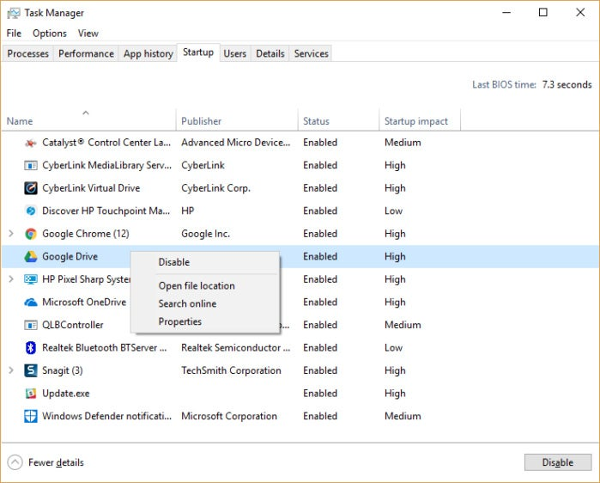](https://images.idgesg.net/images/article/2017/10/new-task-manager-100739466-orig.jpg?auto=webp)](https://images.idgesg.net/images/article/2017/10/new-task-manager-100739466-orig.jpg?auto=webp" \o "<div class='credit'>IDG</div><p>You can use the Task Manager to help get information about programs that launch at startup and disable any you don't need.&nbsp;(Click image to enlarge it.)</p> )

Now that you’ve selected all the programs that you want to disable at startup, the next time you restart your computer, the system will be a lot less concerned with unnecessary programs.

### 3.4 Training on the GoT-HoMIS.

I ware slightly oriented on GoT-HoMIS system dashboard. A system which is used by the local government hospitals in Tanzania.Iwas told how the storesinformation’s of the patient and other clients who are involved. I Also understood on the roles of the system administrator and other things that the user can view

The system at is assigned in six (6) fields parts which are; IT operator (admin), Reception, Casher, OPD, laboratory, pharmacy medical store.

The operation performed in each field is as follows;

1. **IT OPERATOR** is the admin of the system who controls the whole system and makes any changes in the system.
2. **RECEPTION** in this field is where the client registration, insurance verification, corpse registration, client identification, advanced search, change category and summary.

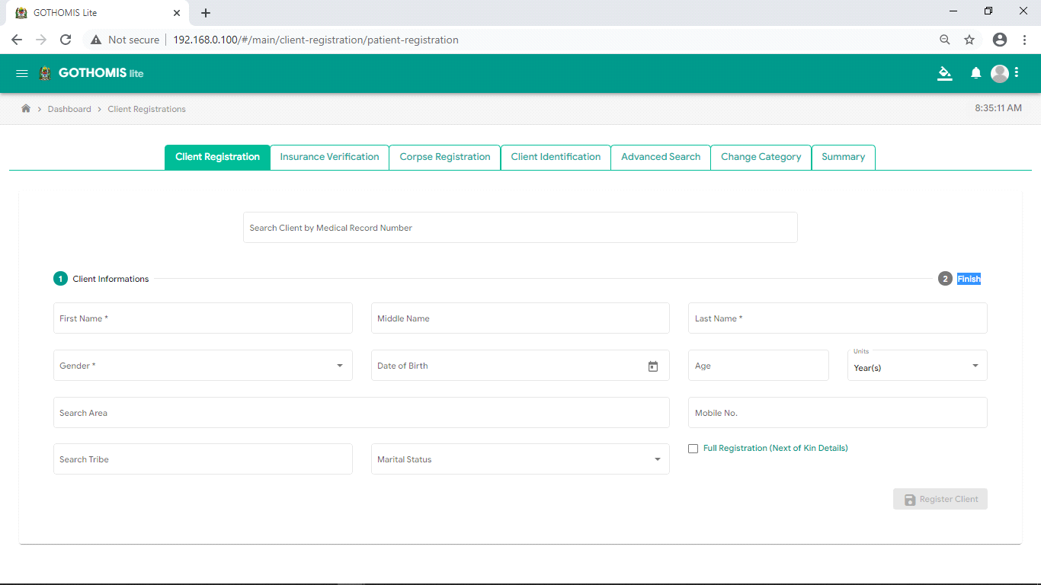

## Figure1. GOT-HOMIS client registration form view.

1. **CASHIER** in this field also client registration is preformed also billing activities such as user fee, insurance cards (NHIF and CHIF).

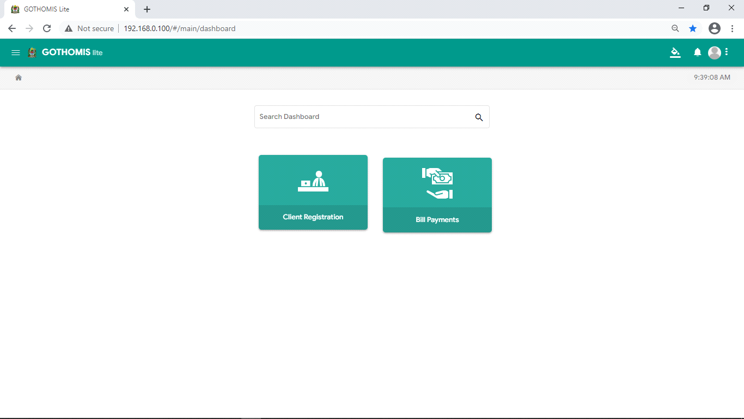

## Figure 2. GOT-HOMIS cashier site tales

1. **OPD** in this field the doctor provides description according patient explanation. Also provides the diagnosis on the diseases according to the laboratory results also writes the medicines to be provided to the patient, also describe the examination testes to be taken from the patient in the laboratory. Also, can provide services for Inpatient, Outpatient, Child Care and Antenatal Care, Family Planning, Labour& Delivery, Report & Requisition and Client Registration.

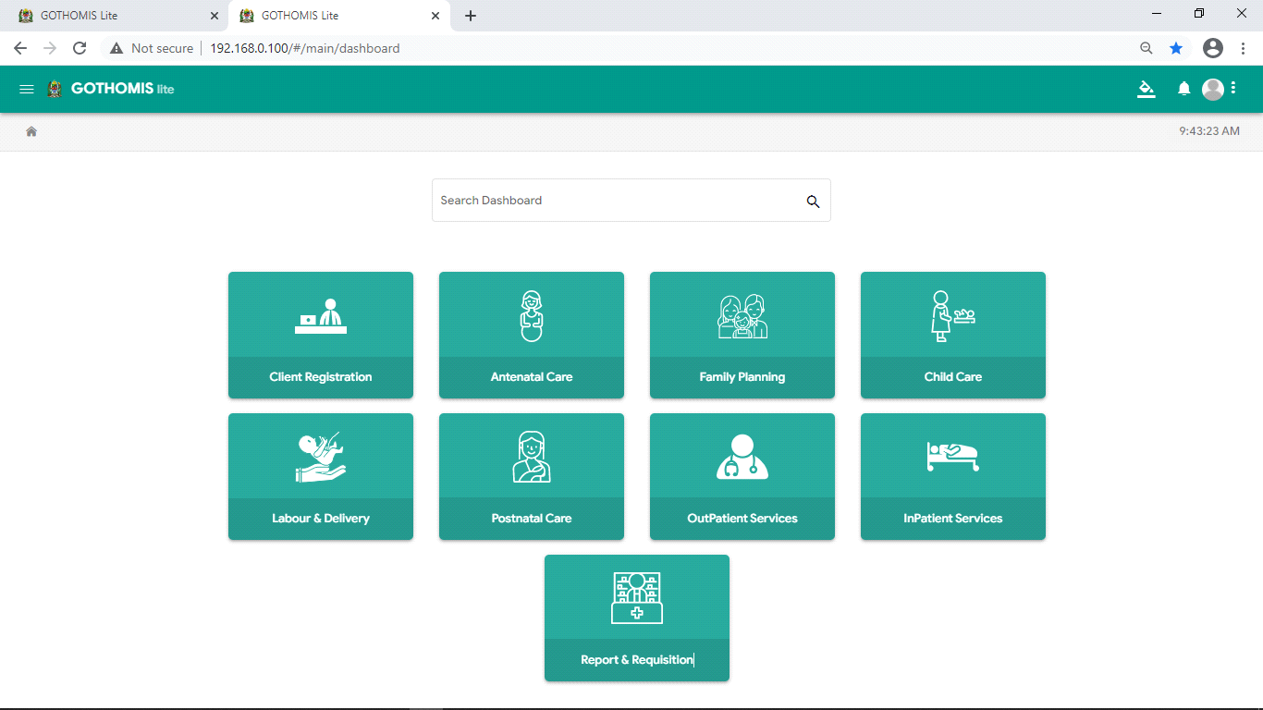

## Figure 3. GOT-HOMIS OPD site tales

1. **LABORATORY** in this field the services provided are such as sample collection, sample approval, sample testing, lab management, blood bank, pharmacy main-store and sample registration.

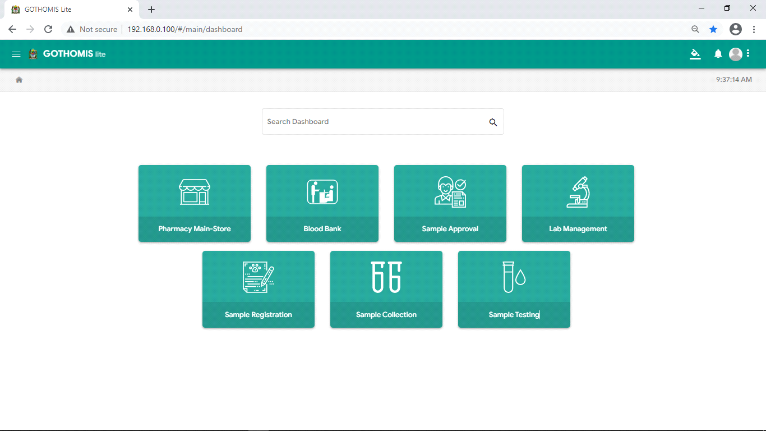

## Figure 4. GOT-HOMIS laboratory site tale.

1. **PHARMACY MEDICAL STORE** the store is of two sides that is main store and the sub-store. Main store is where all the store medicines are recoded and the sub-store is were orders of medicines to main-store is done according to daily or weekly demand of the medicine to patients.

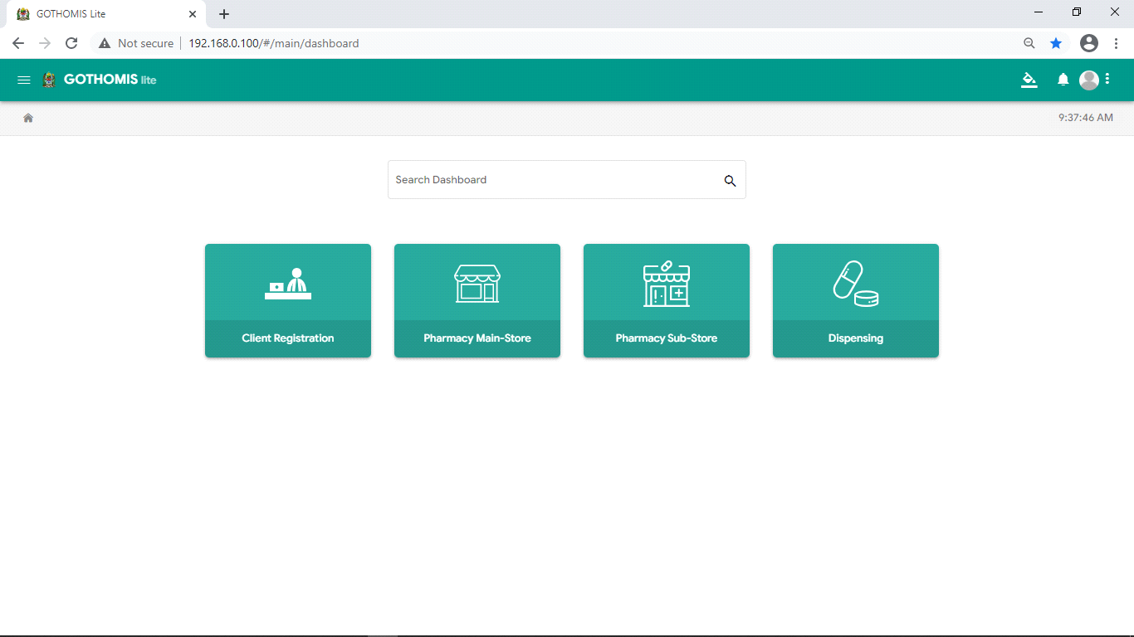

### CHAPTER FOUR

### CHALLENGES

### 4.1 Computer fails to install an operating system

I encountered some computers that couldn't install the operating system with 64 bits due to RAM and the Processor's ability thus to solve the problem installed the operating system with 32 bit and it later worked. Also, other computers wouldn't boot from the CD or external DVD-ROM thus creating a bootable flash and install the operating system by booting the USB devices.

### 4.2 Limited number of staffs.

Misungwi District Council has limited staffs in IT Department in relation to the daily activities. This led to minimal attention to our training expectations.

### 4.3 Access to information

Some of the information related to the duties that we performed could not be accessed directly unless the user (staff member) with an authorized password logs in so as to obtain such information due to security prepose hence in some areas, we come out with inefficient knowledge of doing things.

### CHAPTER FIVE

### CONCLUSION AND RECOMMENDATION

### 5.1 Conclusion

Practical training is a very important program for students to learn and understand the facts about their career. This exposed me to new challenges and opportunities in their profession. Iwas able to do a lot and experience real working environment which is significant for employment preparation or self-employed upon completion of our studies.

During these periodsI understood how to deal with people and different issues concerning my area of professionalism. I also knew how different organizations shape their activities towards the achievement of their goals. Thus, the practical training session is of paramount importance to students as future employers. Moreover, practical training enabled me to understand various fields other than those our career. For instance, at Misungwi District Council I learnt many things about administration and information technology, Health and medical issues which are not part of career as an IT but was something in excess and beneficial. I further gained personal confidence and self-trust as I were working with different people having different managerial positions and different qualifications.

During field attachment I observed the following strengths, Misungwi District Council has a good organizational communication flow which improves the good relationship among the employees. Well defined organizational structure which enables the smooth flow of its operations. Diversified sources of income which gives it strength of operations in a very profitable manner. Wider range of highly skilled and experienced personnel who are working for the best interest of the farmers.High level of technology that enablesCouncil to change with the demand of science technology but the greatest of all I enjoyed working with Misungwi District Council and management to meet my field attachment expectations.

### 5.2 Recommendation.

To improve gaps between teaching theories and practical,The Institute has to look for those courses and try to pursue those courses that had most practical relevance and these will be determined by the recommendation from that companies/organization in which the students used to be placed.Due to rapid changes of technology and advancement of information technology, the Institute should introduce computer practical program in every year of study. The course must be structured in such a way that students go for their Practical Trainings with computer knowledge and not otherwise.

### REFERENCES

<http://misungwidc.go.tz>

<http://www.mwanza.go.tz/organization>

[http://www.searchtelechtarget.com](http://www.searchtelechtarget.com/)

<http://whatis.techtarget.com/definition/processor>

logbook